AGENDA/NOTICE

IDEA Committee Meeting
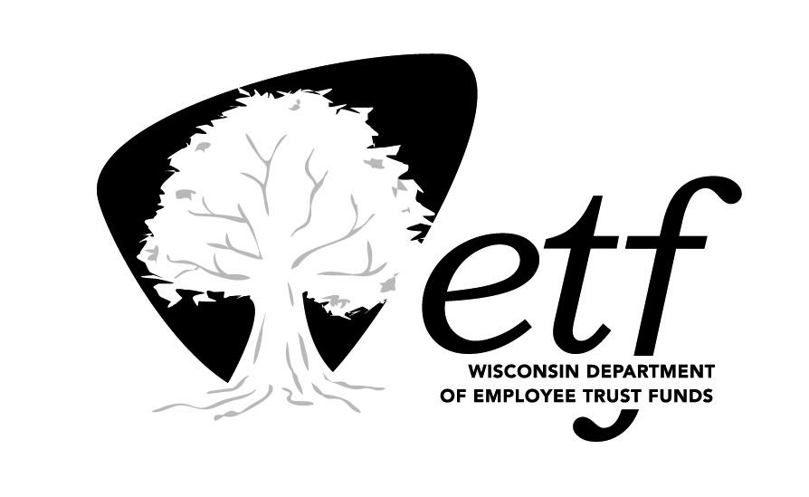
Department of Employee Trust Funds, State of Wisconsin

Tuesday, October 10, 2023
11:00 am-12:30 pm

Remote (Microsoft Teams)

Estimated Time | Topic | Presenter
11:00 am | Call to Order | Alene Kleczek
11:05 am | ETF Community Articles & Observance Calendar  S:\Communications\OfficeOfCommunications\Collaboration\ETF Community\ETFCommunityPlanner.xlsx | Brenda Powles & Jen Bronsdon
11:15 am | E&I plan  -Exercise: What would a successful E&I program at ETF look like to you in 5 years?  -Update on plan.  -IDEA Committee’s role in the E&I Plan. | Brenda Powles
11:35 am | Staff Networking Groups (SNG) | Korbey White
11:40 am | Community Engagement | Korbey White  Everyone
11:45 am | Approval of Minutes: August 2023  https://wigov.sharepoint.com/sites/etf-eip/Shared%20Documents/Forms/AllItems.aspx?FolderCTID=0x01200032D8300CD9365C4CBB80476A85212750&id=%2Fsites%2Fetf%2Deip%2FShared%20Documents%2FMinutes%2F2023&viewid=e0a9a41e%2D0861%2D4eb1%2D8731%2D347a71e4abfd | Alene Kleczek
11:50 am | Other items  - Fall Event  - IDEA Committee and Recruitment | Team
12:30 am | Adjourn | Alene Kleczek

