AGENDA/NOTICE

IDEA Committee Meeting
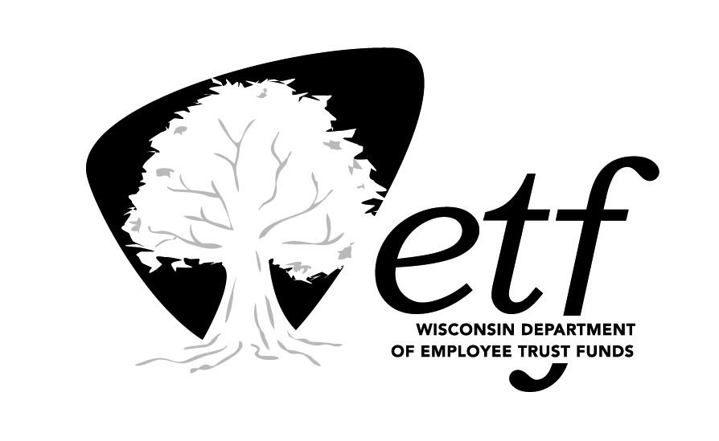
Department of Employee Trust Funds, State of Wisconsin

Tuesday, February 23, 2021
10:00 am – 11:30 am

Remote (Microsoft Teams)
Click here to join the meeting

IMPORTANT NOTICE
Workgroup members will be attending this meeting via teleconference. This is a virtual meeting. Public can access the meeting only via teleconference. No physical access will be available.

Please call (608) 266-8585 for assistance with accessing this meeting.

Estimated Time | Topic | Presenter
10:00 am | Call to Order  Message from the Secretary’s Office | Bob Conlin  John Voelker
10:30 am | Officer Elections | Olga Bilinson
10:35 am | Equity & Inclusion Plan Update | Olga Bilinson/ Korbey White/ Renee Walk
10:45 am | 2021 Priorities and Strategies | Renee Walk  Korbey White  Olga Bilinson
11:15 am | Black History Month Update | Korbey White
11:20 am | EIO Report | Olga Bilinson
11:25 am | Approval of Minutes: December 2020 | Olga Bilinson
11:30 am | Adjourn | Olga Bilinson

Documents for this meeting will be shared electronically. A copy of the agenda is posted at the State Capitol and the Department of Employee Trust Funds website.

